Special Thanks  University of Iowa Deeded Body Program  Jason Salisbury  Dr. Erin Vogel  BCU DPT Class of 2025  BCU Health Science Program  BCU Doctor of Physical Therapy Program  BCU Marketing Team  BCU Events Team  Fleurish Flower Farm    Cover Design by Abagale Ericson |  | 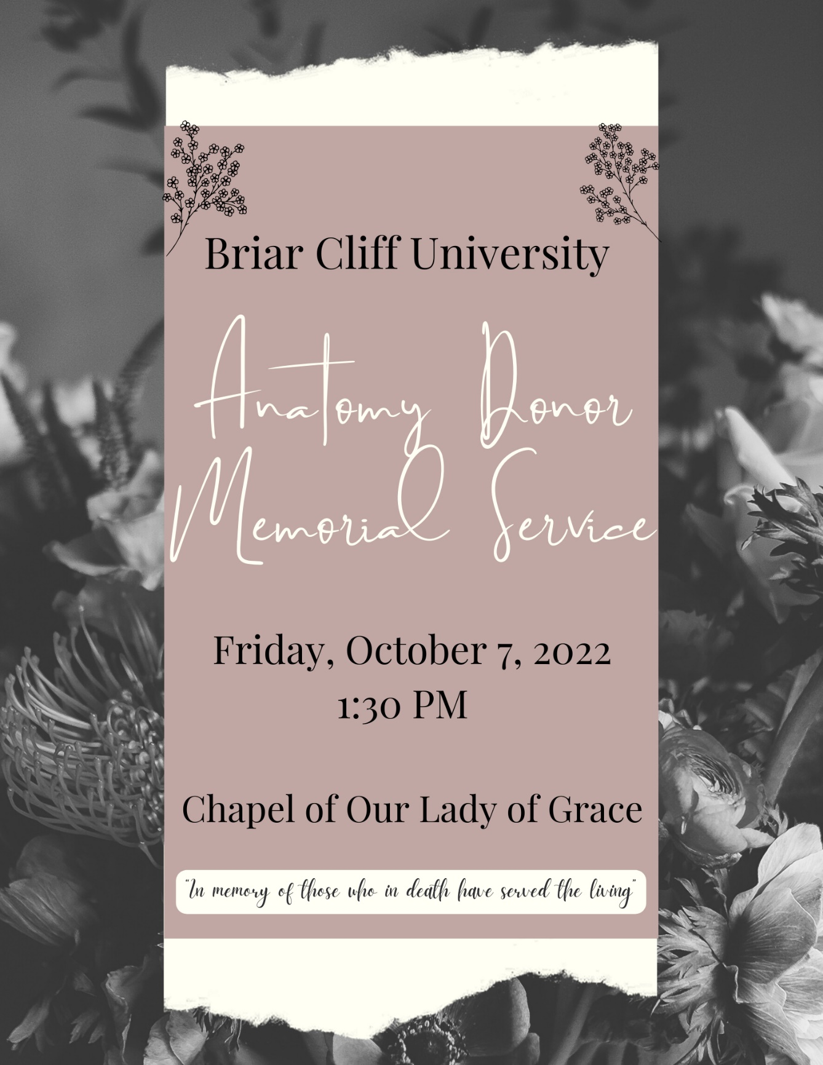

Event Program

Opening Prelude: Dr. Erin Vogel

Welcome and Opening Remarks: Kelsey Stevens

Opening Prayer: Taylor Bietz

Candle Ceremony and Blessing: Jason Salisbury, Director of Campus Ministry and Sophie Kramper

Student Reflections: Clare Caraghar, Dylan Kallhoff, Ashley German, and Janessa Conrad

Quiet Reflection: Jason Salisbury

Closing Prayer: Ashley German
All: Life-giving God, we are humbled in the presence of these donors who have been so generous to us in allowing their bodies to be used for research and learning. We are grateful for all they have taught us as students & staff about the working of the human body. Continue to bless the families and loved ones who were a part of their lives. We pray that their spirits are at peace and are full of the presence of God. May the learnings they provided live on in our lives as we become healers of others. We ask this blessing in the power of your ever-present Spirit of Love. Amen

Closing Song: Briar Cliff Hymn

